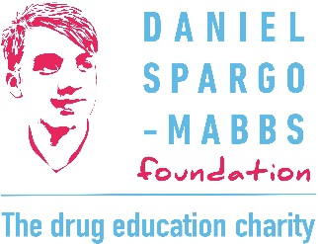

DSM Foundation Community and Corporate Fundraiser
Personal details
Name
Email
Mobile
Current address
Previous name/s
NI no.

Education and training
Educational history and qualifications
Training undertaken (relevant to this role)
Professional membership (if applicable)
Additional skills related to this role

Employment history
Please provide details of all employment including start and end dates and reason for leaving, where applicable. If there are gaps in employment please provide the reason for these. Please add rows if needed.
Organisation | Role | Start date | End date | Reason for leaving/ gap

Please provide information in response to the following person specification criteria
Experience of stewarding donors and building key relationships with individuals and organisations
Experience of planning and delivering a portfolio of successful fundraising events and activities
Experience of learning and using a range of IT software
Ability to use communication skills, both in writing and orally, to motivate and engage others
Ability to manage a varied workload and to multi-task
Experience to work within a small team as well as independently
Experience of working within a diverse community and ability to integrate equalities into all aspects of the work
Passion, commitment and motivation to support young people to make safer choices about drugs

Personal statement
Please explain why you are applying for this role and any additional ways in which you meet the person specification.

References
Please provide names, email addresses and mobile numbers for two referees. These should be people able to vouch for your skills, attitude and appropriateness for this role, and who have known you professionally for at least two years. Please ensure they have given their consent for their details to be shared and a reference requested.
Referee 1 details: | Referee 2 details:

This role is subject to satisfactory Disclosure and Barring Service (DBS) check and references.

Declaration:
The information provided above is accurate and nothing relevant to this application has been omitted.
Signed: _________________________
Date: ______________

Please send this application form to hr@dsmfoundation.org.uk by 12th April 2026

