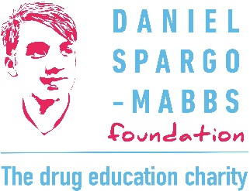

DSM Foundation Drug Education Co-ordinator (Scotland)
Please tell us where you heard about this role:
___________________________________________________________________________
Personal details
Name
Email
Mobile
Current address
Previous name/s
NI no.

Education and training
Educational history and qualifications
Training undertaken (relevant to this role)
Professional membership (if applicable)
Additional skills related to this role

Employment history
Please provide details of all employment including start and end dates and reason for leaving, where applicable. If there are gaps in employment please provide the reason for these. Please add rows if needed.
Organisation | Role | Start date | End date | Reason for leaving/ gap

Please provide information in response to the following person specification criteria
Experience of coordinating events, projects or programmes, meeting deadlines and targets
Organisational skills and confidence to use technology, e.g. spreadsheets and CRM effectively
Ability to work individually and as part of a team, including experience of remote working within a hybrid team setting
Knowledge of substance misuse and particularly its physiological, psychological and social impact (training will be provided for this role where needed).
Experience of relationship building, developing connections, networking and negotiation
Experience of communicating effectively to a range of audiences, both written and verbally, and both internally and externally
An understanding of safeguarding issues, with the ability to support the health and safety of yourself and individuals within projects
Experience of working within a diverse community and ability to integrate equalities into all aspects of the work

Personal statement
Please explain why you are applying for this role, why you want to work for the DSM Foundation, and any additional ways in which you meet the person specification.

References
Please provide names, email addresses and mobile numbers for two referees. These should be people able to vouch for your skills, attitude and appropriateness for this role, and who have known you professionally for at least two years. Please ensure they have given their consent for their details to be shared and a reference requested.
Referee 1 details: | Referee 2 details:

This role is subject to satisfactory Protecting Vulnerable Groups (PVG) check and references.

Declaration:
The information provided above is accurate and nothing relevant to this application has been omitted.
Signed: _________________________
Date: ______________

Please send this application form to hr@dsmfoundation.org.uk
Closing date for applications: 11.30 pm 25th April 2026

